Figure captions

Fig. 1. Arthropod biomass (total grams per branch) among the ten sampled host-plant species. Pooled comparisons are between native and non-native plant groups. Biomass is reported as total wet mass collected from branches. Mean ± SEM is plotted, with levels of significance illustrated for native versus non-native plant groups using grouped, planned contrasts. BE is American beech (Fagus grandifolia), MW is musclewood (*Carpinus caroliniana)*, SH is shadbush (*Amelanchier canadensis*), SM is striped maple (*Acer pennsylvanicum*), SB is sweet birch (*Betula lenta*), WH is witch-hazel (*Hamamelis virginiana*), AO is autumn olive (*Eleagnus umbellata*), BA is Japanese barberry (*Berberis thunbergii*), BU is burning bush (*Eunonymous alatus*) and HS is Morrow’s honeysuckle (*Lonicera morowii*).

Fig. 2. Effect size of bird exclusion treatment among ten sampled host-plant species and pooled comparison between native and non-native plant groups. Bird exclusion effect size reported as Log-Response Ratios (LRR), in which positive values > 0 indicate a significant reduction in arthropod abundance in response to bird predation. Mean ± SEM is plotted, with levels of significance illustrated for native versus non-native plant groups using grouped, planned contrasts. BE is American beech (Fagus grandifolia), MW is musclewood (*Carpinus caroliniana)*, SH is shadbush (*Amelanchier canadensis*), SM is striped maple (*Acer pennsylvanicum*), SB is sweet birch (*Betula lenta*), WH is witch-hazel (*Hamamelis virginiana*), AO is autumn olive (*Eleagnus umbellata*), BA is Japanese barberry (*Berberis thunbergii*), BU is burning bush (*Eunonymous alatus*) and HS is Morrow’s honeysuckle (*Lonicera morowii*).

Fig. 3. Effects of bird-bag exclusion treatment under the context of native versus non-native host-plant groups. Points with lines connecting them are significantly different from each other if they have different letters (Scheffe’s test for pairwise comparisons were completed for each of the eight sub-panels). Each panel indicates the response of a single taxonomic group and changes in Mean ± SEM abundance: 3a. Araneae (true spiders), 3b. Hemiptera (herbivorous true bug families), 3c. Lepidoptera (caterpillars), and 3d. Orthoptera (tree crickets and katydids).

Fig. 4. Total % nitrogen for insect herbivores (4a) and true spiders (4b) among ten host-plant species and pooled comparisons between native and non-native plant groups. Nitrogen content is measured as the total molecular mass of elemental nitrogen relative to total mass of a single sample from an experimental host-plant branch. Only bagged branches were included in analysis (see Fig 1). Mean ± SEM is plotted with levels of significance illustrated for native versus non-native plant groups using grouped, planned contrasts. BE is American beech (Fagus grandifolia), MW is musclewood (*Carpinus caroliniana)*, SH is shadbush (*Amelanchier canadensis*), SM is striped maple (*Acer pennsylvanicum*), SB is sweet birch (*Betula lenta*), WH is witch-hazel (*Hamamelis virginiana*), AO is autumn olive (*Eleagnus umbellata*), BA is Japanese barberry (*Berberis thunbergii*), BU is burning bush (*Eunonymous alatus*) and HS is Morrow’s honeysuckle (*Lonicera morowii*).

Fig. 1.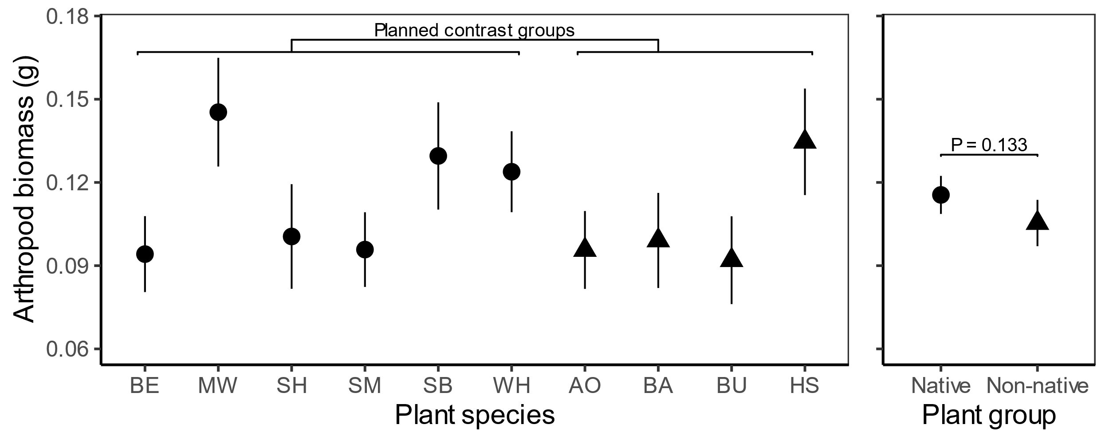

Fig 2.

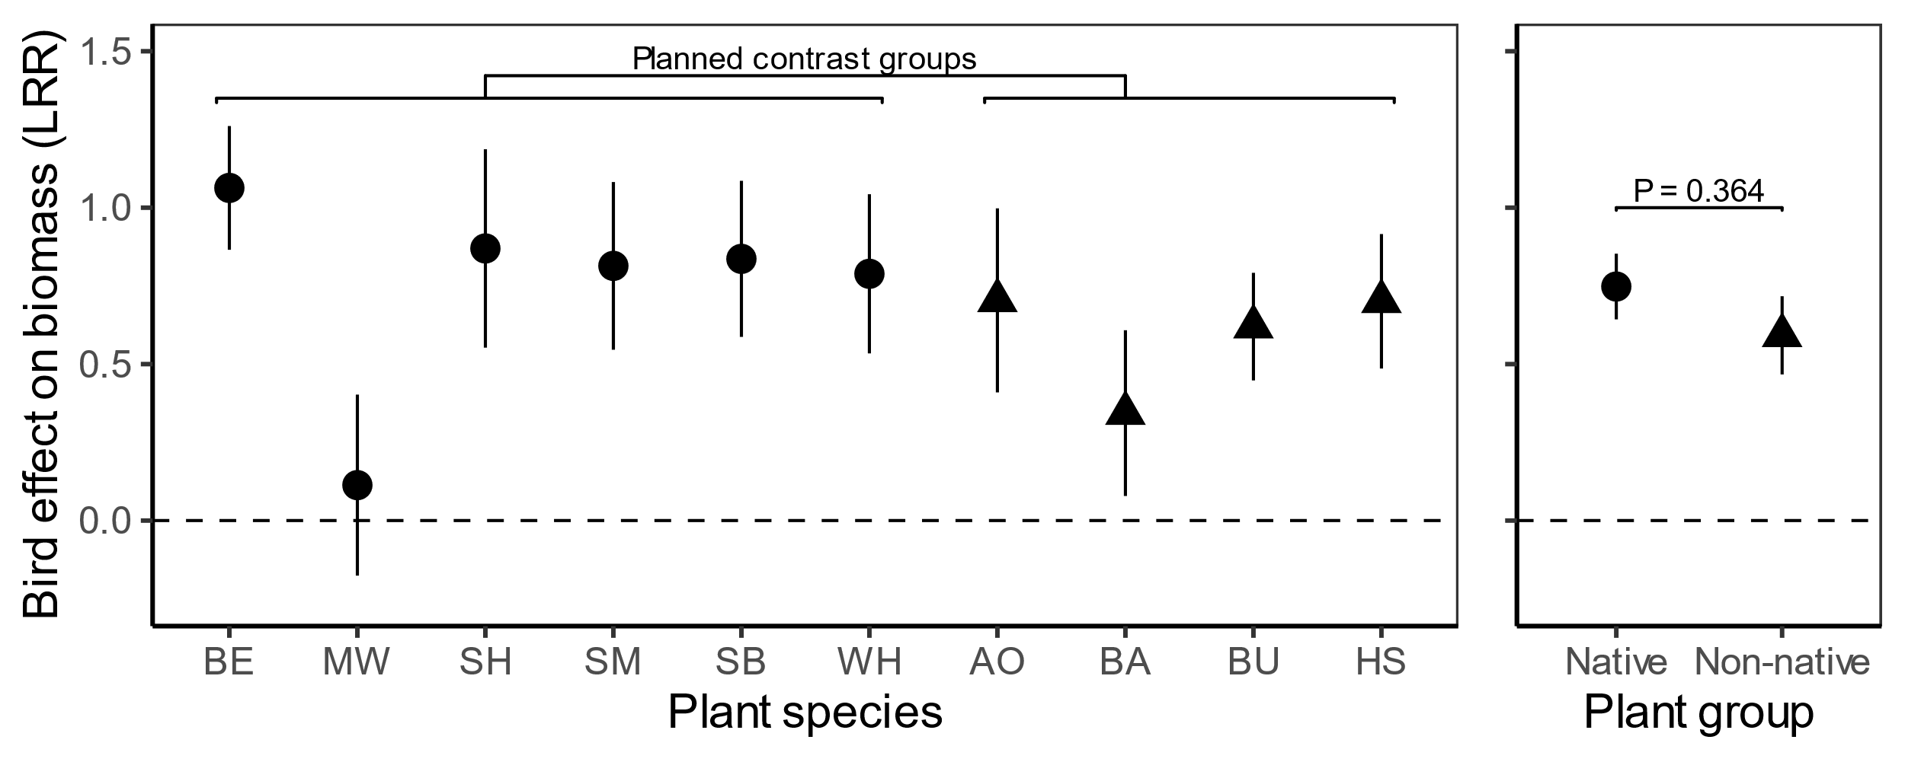

Fig 3a, 3b, 3c, 3d.

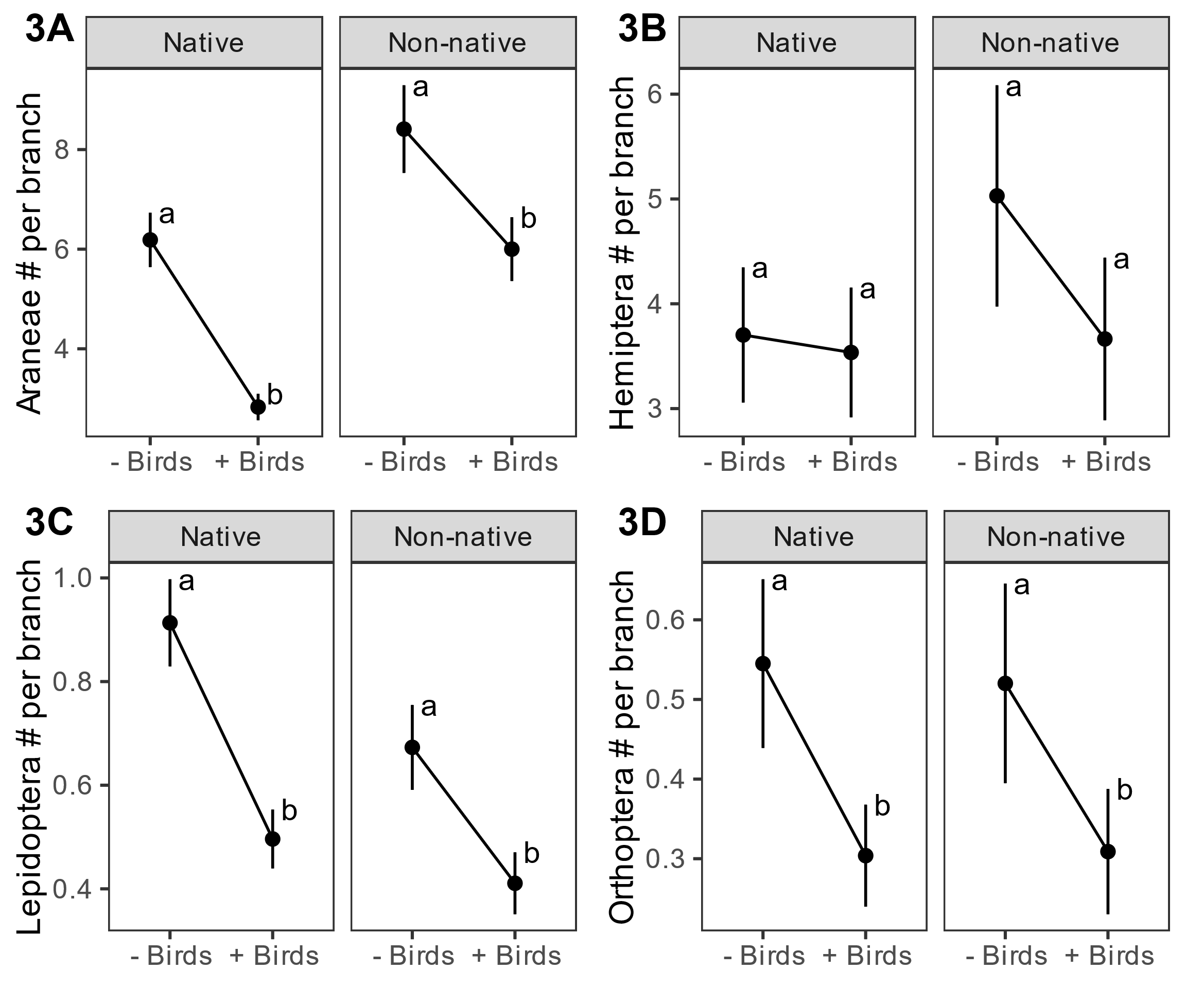

Fig 4a, 4b.

